Name: **RestaurantGUI**

Description: **Chapter 12 – Programming Exercise 7**

**Select dinner items from various list boxes**

Write a C# GUI application that allows the user to choose one item from three available options in each of the categories shown below. Assign the price shown to each item and display the total cost of the selected items when the user clicks a button. Provide directions that tell the user how to use the application. The viewButton is to be designated as the Accept button. The exitButton is to be designated as the Cancel button. Access Keys are to be assigned to all buttons on the GUI. Set the Tab index to a logical order. Design your GUI as shown.

Appetizers

Steak Fries & Cheese 6.99

Shrimp Cocktail 9.99

Stuffed Mushrooms 7.99

Entrees

Lasagna with Meat Sauce 22.00

Linguini with Clam Sauce 20.00

Spaghetti with Marinara Sauce 19.00

Desserts

Cannoli 6.50

Chocolate Truffle 8.50

Tira Mi Su 7.50

Create a Click event method for the viewButton. Within the method, declare any variables needed. Using a series of if-else statements, determine which item in which category is selected using the ListBox and (.SelectedIndex). Accumulate total cost accordingly. Display the total cost information message to the user. Items in the display label are to appear as shown. Set the focus to the ResetButton.

Create a Click event method for the resetButton. Within the method, clear the display label of its contents and deselect each item in each of the ListBoxes. To deselect an item, make the ListBox’s (.SelectedIndex) equal to -1.

Create a Click event method for the exitButton that terminates the application.

Complete the Pseudocode Template document for this programming request. A printed version is due upon arrival to class on lab day.

Use your completed Pseudocode document to create the C# application. Create and save the application to your classroom USB flash drive.

*\*\*\* Sample Program Output on Next Page \*\*\**

GUI When Started

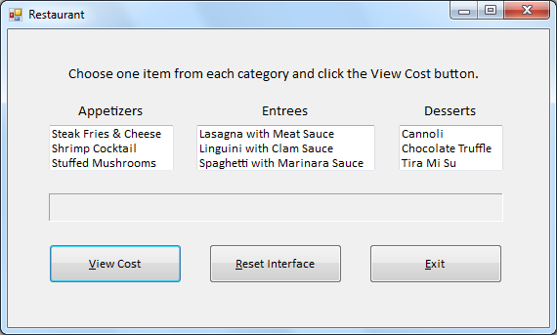

Sample Program Output (1)

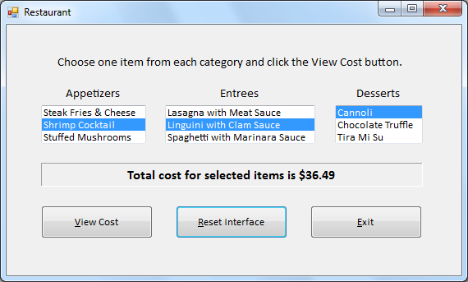

Sample Program Output (Reset Button Clicked)

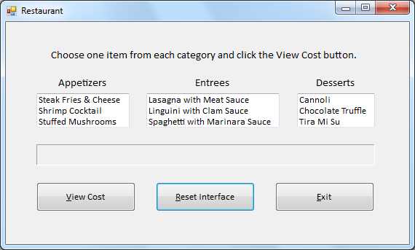

Sample Program Output (2)

